Eyeconic - Glasses Shop Management System

M02 - Edit User

Version 1.0

Revision History

|  |  |  |  |
| --- | --- | --- | --- |
| **Date** | **Version** | **Description** | **Author** |
| 05/11/2019 | 1.0 | Start creating use case | Hoàng Tiến Long |
|  |  |  |  |
|  |  |  |  |
|  |  |  |  |

Table of Contents

1. Edit User 4

1.1 Brief Description 4

1.2 Actor 4

2. Flow of Events 4

2.1 Basic Flow 4

2.2 Exception 5

2.2.1 Edit user 5

2.2.2 Fill in the information form 5

2.2.3 Confirming editing the user 5

3. Special Requirements 5

4. Preconditions 5

4.1 Login 5

5. Postconditions 5

6. Extension Points 5

Use-Case Specification: Edit User

# Edit User

## Brief Description

This use cacse defines the step of editing user.

User are edited by the admin.

## Actor

Administrator.

# Flow of Events

## Basic Flow

In user management, the administrator selects the User data to edit. The administrator changes the needed information. The system displays the updated management parameter value and logs the change.

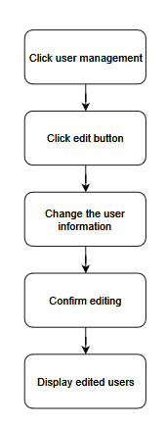

***Basic flow of editing order***

Step 1: Click management user.

Step 2: Click edit button.

Step 3: Change user information.

Step 4: Confirm editing information of user.

Step 5: Display edited user.

## Exception

### Edit user

The edit button cannot be clicked or isn’t appeared on the screen

### Fill in the information form

Invalid information.

Must fill out all the information in the form.

### Confirming editing the user

The “Save” button is clicked but the user is not updated to the database due to the existed user.

# Special Requirements

No Special Requirements

# Preconditions

## Login

Actor must already login as the administrator of the website

Accuracy is required when administrator want to edit user.

# Postconditions

# Extension Points

No extension points.